Hidden-Neurons: 5

iter 0: Train accuracy 0.0625 Test accuracy: 0.1045 \*

iter 100: Train accuracy 0.625 Test accuracy: 0.616 \*

iter 200: Train accuracy 0.65625 Test accuracy: 0.631 \*

iter 300: Train accuracy 0.6875 Test accuracy: 0.636 \*

iter 400: Train accuracy 0.6875 Test accuracy: 0.644 \*

iter 500: Train accuracy 0.625 Test accuracy: 0.653 \*

iter 600: Train accuracy 0.59375 Test accuracy: 0.6575 \*

iter 700: Train accuracy 0.6875 Test accuracy: 0.661 \*

iter 800: Train accuracy 0.8125 Test accuracy: 0.668 \*

iter 900: Train accuracy 0.75 Test accuracy: 0.6715 \*

iter 1000: Train accuracy 0.71875 Test accuracy: 0.6745 \*

iter 1100: Train accuracy 0.5625 Test accuracy: 0.6815 \*

iter 1200: Train accuracy 0.875 Test accuracy: 0.6825 \*

iter 1300: Train accuracy 0.78125 Test accuracy: 0.688 \*

iter 1400: Train accuracy 0.75 Test accuracy: 0.6895 \*

iter 1500: Train accuracy 0.8125 Test accuracy: 0.692 \*

iter 1600: Train accuracy 0.8125 Test accuracy: 0.6935 \*

iter 1700: Train accuracy 0.75 Test accuracy: 0.695 \*

iter 1800: Train accuracy 0.71875 Test accuracy: 0.6955 \*

iter 1900: Train accuracy 0.65625 Test accuracy: 0.696 \*

iter 2000: Train accuracy 0.78125 Test accuracy: 0.6965 \*

iter 2100: Train accuracy 0.6875 Test accuracy: 0.6975 \*

iter 2200: Train accuracy 0.75 Test accuracy: 0.6985 \*

iter 2300: Train accuracy 0.75 Test accuracy: 0.699 \*

iter 2400: Train accuracy 0.78125 Test accuracy: 0.7 \*

iter 2500: Train accuracy 0.6875 Test accuracy: 0.7

iter 2600: Train accuracy 0.625 Test accuracy: 0.7005 \*

iter 2700: Train accuracy 0.8125 Test accuracy: 0.702 \*

iter 2800: Train accuracy 0.75 Test accuracy: 0.7025 \*

iter 2900: Train accuracy 0.8125 Test accuracy: 0.7025

iter 3000: Train accuracy 0.8125 Test accuracy: 0.7045 \*

iter 3100: Train accuracy 0.59375 Test accuracy: 0.7045

iter 3200: Train accuracy 0.71875 Test accuracy: 0.706 \*

iter 3300: Train accuracy 0.71875 Test accuracy: 0.706

iter 3400: Train accuracy 0.78125 Test accuracy: 0.705

iter 3500: Train accuracy 0.84375 Test accuracy: 0.7065 \*

iter 3600: Train accuracy 0.875 Test accuracy: 0.706

iter 3700: Train accuracy 0.71875 Test accuracy: 0.7065

iter 3800: Train accuracy 0.6875 Test accuracy: 0.7065

iter 3900: Train accuracy 0.78125 Test accuracy: 0.708 \*

iter 4000: Train accuracy 0.71875 Test accuracy: 0.71 \*

iter 4100: Train accuracy 0.78125 Test accuracy: 0.7085

iter 4200: Train accuracy 0.75 Test accuracy: 0.7095

iter 4300: Train accuracy 0.8125 Test accuracy: 0.711 \*

iter 4400: Train accuracy 0.75 Test accuracy: 0.7115 \*

iter 4500: Train accuracy 0.875 Test accuracy: 0.7115

iter 4600: Train accuracy 0.75 Test accuracy: 0.7115

iter 4700: Train accuracy 0.71875 Test accuracy: 0.713 \*

iter 4800: Train accuracy 0.65625 Test accuracy: 0.713

iter 4900: Train accuracy 0.75 Test accuracy: 0.713

iter 4999: Train accuracy 0.6875 Test accuracy: 0.713

Time usage: 0:16:51

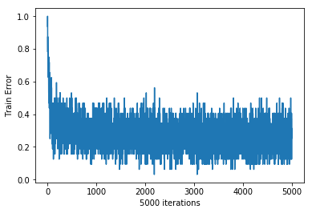

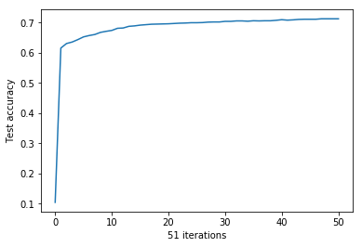

Hidden-Neurons: 10

iter 0: Train accuracy 0 Test accuracy: 0.1195 \*

iter 100: Train accuracy 0.40625 Test accuracy: 0.5195 \*

iter 200: Train accuracy 0.65625 Test accuracy: 0.5795 \*

iter 300: Train accuracy 0.5625 Test accuracy: 0.604 \*

iter 400: Train accuracy 0.59375 Test accuracy: 0.6145 \*

iter 500: Train accuracy 0.59375 Test accuracy: 0.6175 \*

iter 600: Train accuracy 0.65625 Test accuracy: 0.6215 \*

iter 700: Train accuracy 0.78125 Test accuracy: 0.621

iter 800: Train accuracy 0.5625 Test accuracy: 0.624 \*

iter 900: Train accuracy 0.59375 Test accuracy: 0.6315 \*

iter 1000: Train accuracy 0.6875 Test accuracy: 0.6375 \*

iter 1100: Train accuracy 0.65625 Test accuracy: 0.6485 \*

iter 1200: Train accuracy 0.6875 Test accuracy: 0.6755 \*

iter 1300: Train accuracy 0.6875 Test accuracy: 0.7235 \*

iter 1400: Train accuracy 0.71875 Test accuracy: 0.79 \*

iter 1500: Train accuracy 0.8125 Test accuracy: 0.8135 \*

iter 1600: Train accuracy 0.75 Test accuracy: 0.812

iter 1700: Train accuracy 0.75 Test accuracy: 0.813

iter 1800: Train accuracy 0.90625 Test accuracy: 0.813

iter 1900: Train accuracy 0.8125 Test accuracy: 0.812

iter 2000: Train accuracy 0.84375 Test accuracy: 0.813

iter 2100: Train accuracy 0.71875 Test accuracy: 0.812

iter 2200: Train accuracy 0.84375 Test accuracy: 0.8135

iter 2300: Train accuracy 0.875 Test accuracy: 0.8145 \*

iter 2400: Train accuracy 0.90625 Test accuracy: 0.8135

iter 2500: Train accuracy 0.875 Test accuracy: 0.8155 \*

iter 2600: Train accuracy 0.78125 Test accuracy: 0.816 \*

iter 2700: Train accuracy 0.875 Test accuracy: 0.815

iter 2800: Train accuracy 0.75 Test accuracy: 0.8155

iter 2900: Train accuracy 0.8125 Test accuracy: 0.816

iter 3000: Train accuracy 0.84375 Test accuracy: 0.815

iter 3100: Train accuracy 0.875 Test accuracy: 0.8165 \*

iter 3200: Train accuracy 0.9375 Test accuracy: 0.816

iter 3300: Train accuracy 0.8125 Test accuracy: 0.815

iter 3400: Train accuracy 0.78125 Test accuracy: 0.8165

iter 3500: Train accuracy 0.90625 Test accuracy: 0.816

iter 3600: Train accuracy 0.875 Test accuracy: 0.817 \*

iter 3700: Train accuracy 0.90625 Test accuracy: 0.8165

iter 3800: Train accuracy 0.90625 Test accuracy: 0.8175 \*

iter 3900: Train accuracy 0.875 Test accuracy: 0.8165

iter 4000: Train accuracy 0.84375 Test accuracy: 0.8185 \*

iter 4100: Train accuracy 0.8125 Test accuracy: 0.817

iter 4200: Train accuracy 0.75 Test accuracy: 0.8175

iter 4300: Train accuracy 0.875 Test accuracy: 0.817

iter 4400: Train accuracy 0.75 Test accuracy: 0.817

iter 4500: Train accuracy 0.78125 Test accuracy: 0.8175

iter 4600: Train accuracy 0.875 Test accuracy: 0.8165

iter 4700: Train accuracy 0.9375 Test accuracy: 0.8175

iter 4800: Train accuracy 0.875 Test accuracy: 0.8175

iter 4900: Train accuracy 0.75 Test accuracy: 0.8185

iter 4999: Train accuracy 0.875 Test accuracy: 0.8175

Time usage: 0:16:01

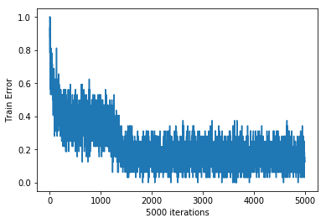

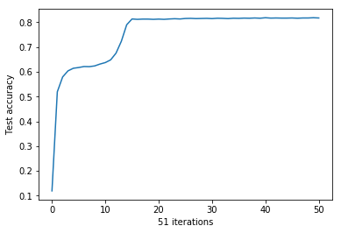

Hidden-Neurons: 15

iter 0: Train accuracy 0.125 Test accuracy: 0.1185 \*

iter 100: Train accuracy 0.59375 Test accuracy: 0.6215 \*

iter 200: Train accuracy 0.65625 Test accuracy: 0.628 \*

iter 300: Train accuracy 0.78125 Test accuracy: 0.632 \*

iter 400: Train accuracy 0.875 Test accuracy: 0.6345 \*

iter 500: Train accuracy 0.53125 Test accuracy: 0.6365 \*

iter 600: Train accuracy 0.59375 Test accuracy: 0.642 \*

iter 700: Train accuracy 0.65625 Test accuracy: 0.6445 \*

iter 800: Train accuracy 0.5625 Test accuracy: 0.648 \*

iter 900: Train accuracy 0.71875 Test accuracy: 0.6515 \*

iter 1000: Train accuracy 0.75 Test accuracy: 0.663 \*

iter 1100: Train accuracy 0.75 Test accuracy: 0.683 \*

iter 1200: Train accuracy 0.78125 Test accuracy: 0.7415 \*

iter 1300: Train accuracy 0.84375 Test accuracy: 0.754 \*

iter 1400: Train accuracy 0.8125 Test accuracy: 0.7635 \*

iter 1500: Train accuracy 0.9375 Test accuracy: 0.7715 \*

iter 1600: Train accuracy 0.875 Test accuracy: 0.777 \*

iter 1700: Train accuracy 0.9375 Test accuracy: 0.7795 \*

iter 1800: Train accuracy 0.59375 Test accuracy: 0.7865 \*

iter 1900: Train accuracy 0.78125 Test accuracy: 0.791 \*

iter 2000: Train accuracy 0.90625 Test accuracy: 0.792 \*

iter 2100: Train accuracy 0.78125 Test accuracy: 0.7935 \*

iter 2200: Train accuracy 0.875 Test accuracy: 0.794 \*

iter 2300: Train accuracy 0.75 Test accuracy: 0.7945 \*

iter 2400: Train accuracy 0.96875 Test accuracy: 0.795 \*

iter 2500: Train accuracy 0.75 Test accuracy: 0.7955 \*

iter 2600: Train accuracy 0.8125 Test accuracy: 0.7965 \*

iter 2700: Train accuracy 0.84375 Test accuracy: 0.7985 \*

iter 2800: Train accuracy 0.9375 Test accuracy: 0.7995 \*

iter 2900: Train accuracy 0.84375 Test accuracy: 0.7995

iter 3000: Train accuracy 0.8125 Test accuracy: 0.7995

iter 3100: Train accuracy 0.90625 Test accuracy: 0.802 \*

iter 3200: Train accuracy 0.78125 Test accuracy: 0.802

iter 3300: Train accuracy 0.84375 Test accuracy: 0.8015

iter 3400: Train accuracy 0.78125 Test accuracy: 0.8035 \*

iter 3500: Train accuracy 0.84375 Test accuracy: 0.8045 \*

iter 3600: Train accuracy 0.875 Test accuracy: 0.8055 \*

iter 3700: Train accuracy 0.9375 Test accuracy: 0.805

iter 3800: Train accuracy 0.8125 Test accuracy: 0.8065 \*

iter 3900: Train accuracy 0.84375 Test accuracy: 0.807 \*

iter 4000: Train accuracy 0.9375 Test accuracy: 0.8065

iter 4100: Train accuracy 0.875 Test accuracy: 0.807

iter 4200: Train accuracy 0.84375 Test accuracy: 0.807

iter 4300: Train accuracy 0.84375 Test accuracy: 0.8075 \*

iter 4400: Train accuracy 0.875 Test accuracy: 0.8075

iter 4500: Train accuracy 0.78125 Test accuracy: 0.808 \*

iter 4600: Train accuracy 0.84375 Test accuracy: 0.8075

iter 4700: Train accuracy 0.8125 Test accuracy: 0.808

iter 4800: Train accuracy 0.75 Test accuracy: 0.8075

iter 4900: Train accuracy 0.84375 Test accuracy: 0.8085 \*

iter 4999: Train accuracy 0.875 Test accuracy: 0.808

Time usage: 0:16:39

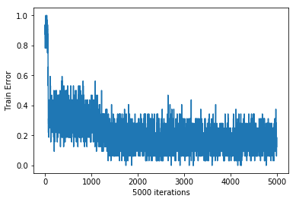

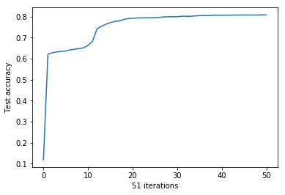

Hidden-Neurons: 20

iter 0: Train accuracy 0.03125 Test accuracy: 0.019 \*

iter 100: Train accuracy 0.46875 Test accuracy: 0.4705 \*

iter 200: Train accuracy 0.75 Test accuracy: 0.7035 \*

iter 300: Train accuracy 0.71875 Test accuracy: 0.6915

iter 400: Train accuracy 0.71875 Test accuracy: 0.687

iter 500: Train accuracy 0.6875 Test accuracy: 0.6915

iter 600: Train accuracy 0.6875 Test accuracy: 0.6935

iter 700: Train accuracy 0.625 Test accuracy: 0.695

iter 800: Train accuracy 0.71875 Test accuracy: 0.6965

iter 900: Train accuracy 0.5625 Test accuracy: 0.695

iter 1000: Train accuracy 0.75 Test accuracy: 0.695

iter 1100: Train accuracy 0.6875 Test accuracy: 0.696

iter 1200: Train accuracy 0.6875 Test accuracy: 0.697

iter 1300: Train accuracy 0.78125 Test accuracy: 0.697

iter 1400: Train accuracy 0.75 Test accuracy: 0.698

iter 1500: Train accuracy 0.75 Test accuracy: 0.7

iter 1600: Train accuracy 0.625 Test accuracy: 0.699

iter 1700: Train accuracy 0.71875 Test accuracy: 0.7

iter 1800: Train accuracy 0.8125 Test accuracy: 0.7005

iter 1900: Train accuracy 0.59375 Test accuracy: 0.7015

iter 2000: Train accuracy 0.8125 Test accuracy: 0.702

iter 2100: Train accuracy 0.84375 Test accuracy: 0.702

iter 2200: Train accuracy 0.65625 Test accuracy: 0.702

iter 2300: Train accuracy 0.75 Test accuracy: 0.703

iter 2400: Train accuracy 0.75 Test accuracy: 0.7035

iter 2500: Train accuracy 0.71875 Test accuracy: 0.704 \*

iter 2600: Train accuracy 0.8125 Test accuracy: 0.703

iter 2700: Train accuracy 0.71875 Test accuracy: 0.705 \*

iter 2800: Train accuracy 0.71875 Test accuracy: 0.704

iter 2900: Train accuracy 0.6875 Test accuracy: 0.706 \*

iter 3000: Train accuracy 0.78125 Test accuracy: 0.7055

iter 3100: Train accuracy 0.78125 Test accuracy: 0.7075 \*

iter 3200: Train accuracy 0.6875 Test accuracy: 0.707

iter 3300: Train accuracy 0.84375 Test accuracy: 0.708 \*

iter 3400: Train accuracy 0.78125 Test accuracy: 0.708

iter 3500: Train accuracy 0.625 Test accuracy: 0.7085 \*

iter 3600: Train accuracy 0.75 Test accuracy: 0.71 \*

iter 3700: Train accuracy 0.84375 Test accuracy: 0.7095

iter 3800: Train accuracy 0.75 Test accuracy: 0.7085

iter 3900: Train accuracy 0.78125 Test accuracy: 0.7105 \*

iter 4000: Train accuracy 0.78125 Test accuracy: 0.712 \*

iter 4100: Train accuracy 0.75 Test accuracy: 0.713 \*

iter 4200: Train accuracy 0.78125 Test accuracy: 0.7135 \*

iter 4300: Train accuracy 0.75 Test accuracy: 0.715 \*

iter 4400: Train accuracy 0.78125 Test accuracy: 0.715

iter 4500: Train accuracy 0.84375 Test accuracy: 0.7175 \*

iter 4600: Train accuracy 0.78125 Test accuracy: 0.7195 \*

iter 4700: Train accuracy 0.71875 Test accuracy: 0.719

iter 4800: Train accuracy 0.71875 Test accuracy: 0.7185

iter 4900: Train accuracy 0.6875 Test accuracy: 0.719

iter 4999: Train accuracy 0.84375 Test accuracy: 0.7195

Time usage: 0:17:04

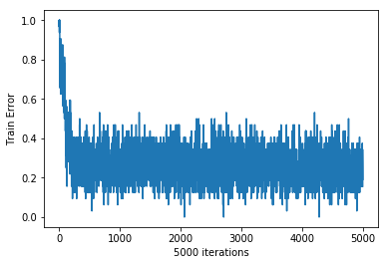

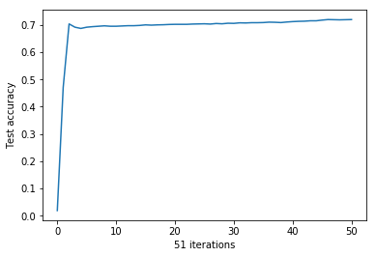

Hidden-Neurons: 25

iter 0: Train accuracy 0.15625 Test accuracy: 0.235 \*

iter 100: Train accuracy 0.5 Test accuracy: 0.4655 \*

iter 200: Train accuracy 0.46875 Test accuracy: 0.466 \*

iter 300: Train accuracy 0.5 Test accuracy: 0.468 \*

iter 400: Train accuracy 0.5 Test accuracy: 0.4735 \*

iter 500: Train accuracy 0.4375 Test accuracy: 0.506 \*

iter 600: Train accuracy 0.53125 Test accuracy: 0.556 \*

iter 700: Train accuracy 0.4375 Test accuracy: 0.5615 \*

iter 800: Train accuracy 0.46875 Test accuracy: 0.5655 \*

iter 900: Train accuracy 0.625 Test accuracy: 0.569 \*

iter 1000: Train accuracy 0.5 Test accuracy: 0.571 \*

iter 1100: Train accuracy 0.5625 Test accuracy: 0.5715 \*

iter 1200: Train accuracy 0.625 Test accuracy: 0.5725 \*

iter 1300: Train accuracy 0.5 Test accuracy: 0.5725

iter 1400: Train accuracy 0.5625 Test accuracy: 0.5725

iter 1500: Train accuracy 0.5 Test accuracy: 0.5725

iter 1600: Train accuracy 0.6875 Test accuracy: 0.5725

iter 1700: Train accuracy 0.5625 Test accuracy: 0.5735 \*

iter 1800: Train accuracy 0.4375 Test accuracy: 0.5735

iter 1900: Train accuracy 0.5 Test accuracy: 0.5735

iter 2000: Train accuracy 0.5625 Test accuracy: 0.5735

iter 2100: Train accuracy 0.4375 Test accuracy: 0.5735

iter 2200: Train accuracy 0.59375 Test accuracy: 0.574 \*

iter 2300: Train accuracy 0.59375 Test accuracy: 0.574

iter 2400: Train accuracy 0.65625 Test accuracy: 0.5745 \*

iter 2500: Train accuracy 0.59375 Test accuracy: 0.5745

iter 2600: Train accuracy 0.5625 Test accuracy: 0.5745

iter 2700: Train accuracy 0.53125 Test accuracy: 0.5745

iter 2800: Train accuracy 0.5 Test accuracy: 0.5745

iter 2900: Train accuracy 0.5625 Test accuracy: 0.5745

iter 3000: Train accuracy 0.65625 Test accuracy: 0.5745

iter 3100: Train accuracy 0.5 Test accuracy: 0.5745

iter 3200: Train accuracy 0.5625 Test accuracy: 0.5745

iter 3300: Train accuracy 0.65625 Test accuracy: 0.5745

iter 3400: Train accuracy 0.625 Test accuracy: 0.5745

iter 3500: Train accuracy 0.59375 Test accuracy: 0.5745

iter 3600: Train accuracy 0.5625 Test accuracy: 0.5745

iter 3700: Train accuracy 0.625 Test accuracy: 0.5745

iter 3800: Train accuracy 0.5 Test accuracy: 0.5745

iter 3900: Train accuracy 0.625 Test accuracy: 0.5745

iter 4000: Train accuracy 0.625 Test accuracy: 0.5745

iter 4100: Train accuracy 0.5 Test accuracy: 0.5745

iter 4200: Train accuracy 0.625 Test accuracy: 0.5745

iter 4300: Train accuracy 0.46875 Test accuracy: 0.5745

iter 4400: Train accuracy 0.65625 Test accuracy: 0.5745

iter 4500: Train accuracy 0.625 Test accuracy: 0.575 \*

iter 4600: Train accuracy 0.65625 Test accuracy: 0.575

iter 4700: Train accuracy 0.46875 Test accuracy: 0.575

iter 4800: Train accuracy 0.5625 Test accuracy: 0.575

iter 4900: Train accuracy 0.40625 Test accuracy: 0.575

iter 4999: Train accuracy 0.65625 Test accuracy: 0.575

Time usage: 0:15:49

